Problem of the Week

Feb. 3 - Due Feb. 7

Storage Lockers
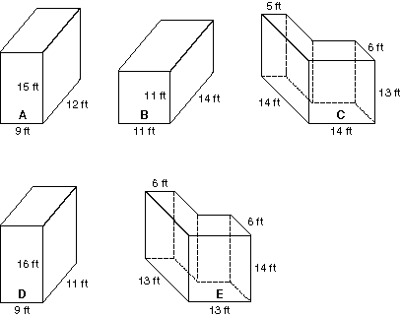
Doreen, Cheri, Jarrod, Laura, and Troy are helping their families load the storage lockers each family has rented. Each storage locker is a different size.
- Troy's family rented the locker with the greatest volume.
- Laura's family rented the one with the least volume.
- The storage area of the locker rented by Jarrod's family is greater than that of the locker rented by Doreen's family.
- The locker rented by Cheri's family is smaller than the one Doreen's family has rented.
Which storage locker has each family rented?
What is the volume of each locker in cubic feet?

